Power BI Dashboard Screenshots

OVERVIEW

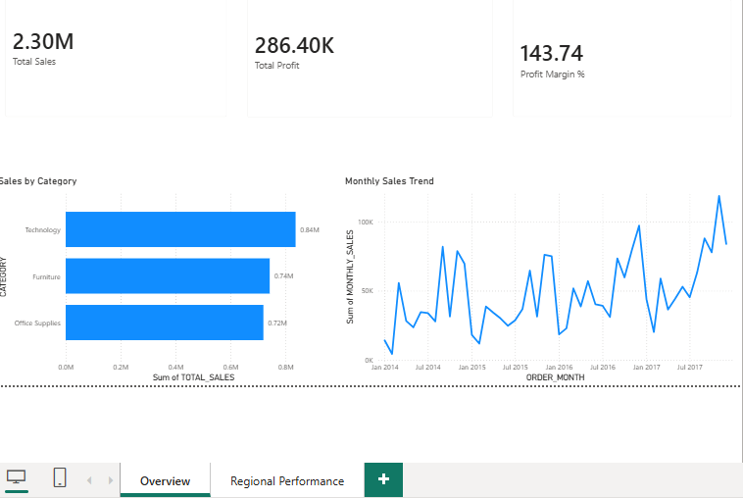

REGIONAL PERFORMANCE
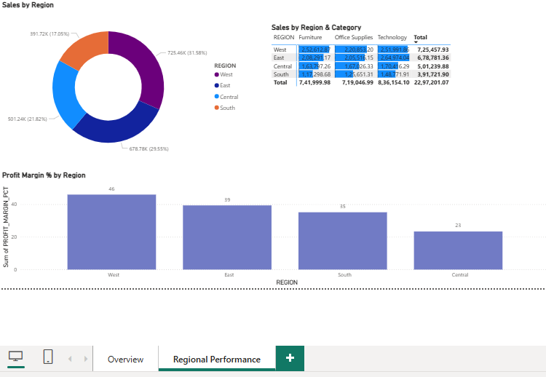

PRODUCT ANALYSIS
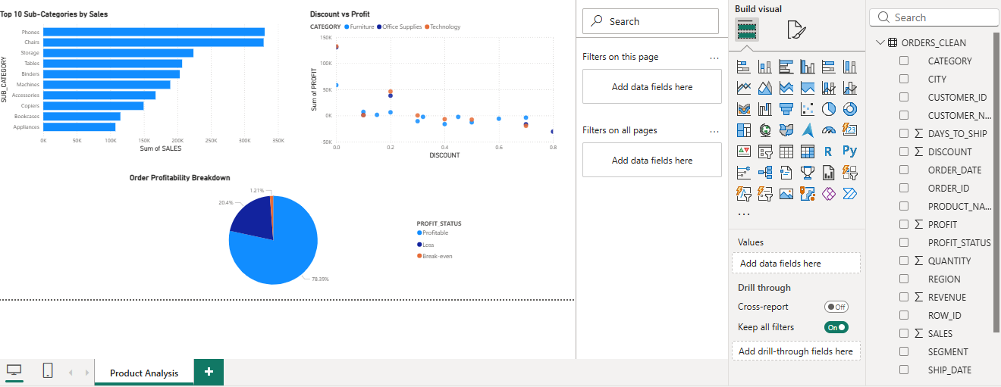

CUSTOMER INSIGHTS
